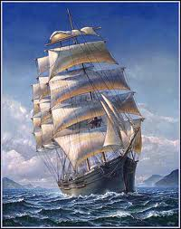
All aboard!
No. 35 SPRING 2023
All us Catholics on board together
A quarterly Newsletter of encouragement for all Catholics in the parish of St. Pius X, Heidelberg West.

What happened to St. Bernadette? (After her vision at Lourdes)
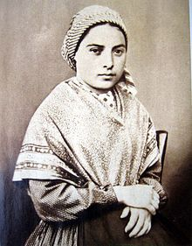
Disliking the attention she was attracting, Bernadette went to the hospice school run by the Sisters of Charity of Nevers where she had learned to read and write. Although she considered joining the Carmelites, her health precluded her entering any of the strict contemplative orders. On 29 July 1866, with 42 other candidates, she took the religious habit of a postulant and joined the Sisters of Charity at their motherhouse at Nevers. Her Mistress of Novices was Sister Marie Therese Vauzou. The Mother Superior at the time gave her the name Marie-Bernarde in honor of her godmother who was named "Bernarde".
Bernadette spent the rest of her brief life there, working as an assistant in the infirmary and later as a sacristan, creating beautiful embroidery for altar cloths and vestments. Her contemporaries admired her humility and spirit of sacrifice. One day, asked about the apparitions, she replied:
“The Virgin used me as a broom to remove the dust. When the work is done, the broom is put behind the door again.”
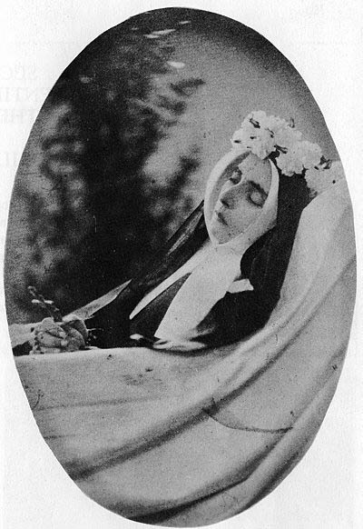
She later contracted tuberculosis of the bone in her right knee. She had followed the development of Lourdes as a pilgrimage shrine while she still lived at Lourdes, but was not present for the consecration of the Basilica of the Immaculate Conception there in 1876.
For several months prior to her death, she was unable to take an active part in convent life. She eventually died of her long-term illness at the age of 35 on 16 April 1879, while praying the holy rosary. On her deathbed, as she suffered from severe pain and in keeping with the Virgin Mary's admonition of "Penance, Penance, Penance," Bernadette proclaimed that "all this is good for Heaven!" Her final words were, "Blessed Mary, Mother of God, pray for me! A poor sinner, a poor sinner-" Bernadette's body was laid to rest in the Saint Gildard Convent.
^^^^^^^^^^^^^^^^^^^^^^^^^^^^^^^^^^^^^^^^^^^^^^^^^^^^^^^^^^^^^^^^^^^^^^^^^^^^^^^^^^^^^^^^^^^^

What are the people like around here?
A traveller was entering a city and asked a local what the people were like in her city. The local asked the traveller what the people were like in his city. He said they were thoughtful and kind and honest. The local said: “That’s exactly how you will find the people here.”
A different traveller came along soon after and asked the same question: “What are the people like in your city?” But before answering the local asked the second traveller: “How do you find the people in your own city?” The traveller explained that in his city the people were selfish, rude and dishonest. The local said: “That’s just how you will find people here!”
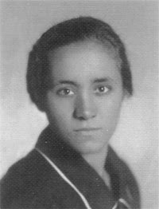
Mother Teresa early years Mother Teresa of Calcutta (1910-1997)
“By blood, I am Albanian. By citizenship, an Indian. By faith, I am a Catholic nun. As to my calling, I belong to the world. As to my heart, I belong entirely to the Heart of Jesus. ”Small of stature, rocklike in faith, Mother Teresa of Calcutta was entrusted with the mission of proclaiming God’s thirsting love for humanity, especially for the poorest of the poor. “God still loves the world and He sends you and me to be His love and His compassion to the poor.” She was a soul filled with the light of Christ, on fire with love for Him and burning with one desire: “to quench His thirst for love and for souls.”
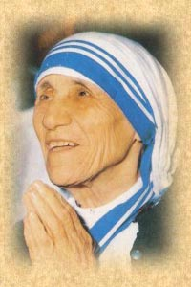
This luminous messenger of God’s love was born on 26 August 1910 in Skopje, a city situated at the crossroads of Balkan history. The youngest of the children born to Nikola and Drane Bojaxhiu, she was baptised Gonxha Agnes, received her First Communion at the age of five and a half and was confirmed in November 1916. From the day of her First Holy Communion, a love for souls was within her. Her father’s sudden death when Gonxha was about eight years old left the family in financial straits. Drane raised her children firmly and lovingly, greatly influencing her daughter’s character and vocation. Gonxha’s religious formation was further assisted by the vibrant Jesuit parish of the Sacred Heart in which she was much involved.
At the age of eighteen, moved by a desire to become a missionary, Gonxha left her home in September 1928 to join the Institute of the Blessed Virgin Mary, known as the Sisters of Loreto, in Ireland. There she received the name Sister Mary Teresa after St. Thérèse of Lisieux. In December, she departed for India, arriving in Calcutta on 6 January 1929. After making her First Profession of Vows in May 1931, Sister Teresa was assigned to the Loreto Entally community in Calcutta and taught at St. Mary’s School for girls. On 24 May 1937, Sister Teresa made her Final Profession of Vows, becoming, as she said, the “spouse of Jesus” for “all eternity.” From that time on she was called Mother Teresa. She continued teaching at St. Mary’s and in 1944 became the school’s principal. A person of profound prayer and deep love for her religious sisters and her students, Mother Teresa’s twenty years in Loreto were filled with profound happiness. Noted for her charity, unselfishness and courage, her capacity for hard work and a natural talent for organization, she lived out her consecration to Jesus, in the midst of her companions, with fidelity and joy.
On 10 September 1946 during the train ride from Calcutta to Darjeeling for her annual retreat, Mother Teresa received her “inspiration,” her “call within a call.” On that day, in a way she would never explain, Jesus’ thirst for love and for souls took hold of her heart and the desire to satiate His thirst became the driving force of her life. Over the course of the next weeks and months, by means of interior locutions and visions, Jesus revealed to her the desire of His heart for “victims of love” who would “radiate His love on souls.” “Come be My light,” He begged her. “I cannot go alone.” He revealed His pain at the neglect of the poor, His sorrow at their ignorance of Him and His longing for their love. He asked Mother Teresa to establish a religious community, Missionaries of Charity, dedicated to the service of the poorest of the poor. Nearly two years of testing and discernment passed before Mother Teresa received permission to begin. On August 17, 1948, she dressed for the first time in a white, blue-bordered sari and passed through the gates of her beloved Loreto convent to enter the world of the poor.
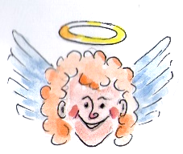
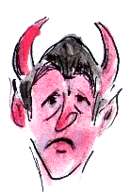
“I must get off my backside and actually do something for others … those less fortunate than myself!”
“Naah! We Catholics don’t have to do anything selfless like that …
St. Vincent de Paul looks after all of that for us!
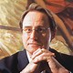
FortyReasons To Be Cheerful
Those with the internet can call up on YouTube Australian composer Graeme Koehne’s: Forty Reasons To Be Cheerful (Festive Fanfare). It’s bright and happy and lively. And we might well recall that one of the Fruits of the Holy Spirit is JOY.

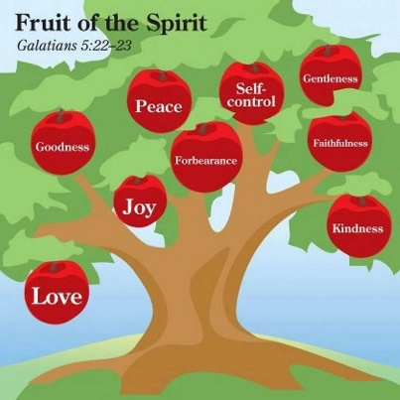
Fruits of the Holy Spirit:

love, joy, peace, patience, kindness, goodness, faithfulness, gentleness, and self-control.

^^^^^^^^^^^^^^^^^^^^^^^^^^^^^^^^^^^^^^^^^^^^^^^^^^^^^^^^^^^^^^^^^^^^^^^^^^^^^^^^^^^^^^^^^^^^^^
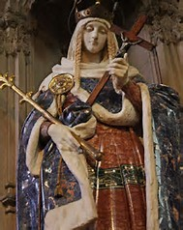
St Margaret of Scotland Saint Margaret of Scotland (c. 1045 – 16 November 1093), also known as Margaret of Wessex, was an English princess of the House of Wessex. Margaret was sometimes called "The Pearl of Scotland". Born in exile in the Kingdom of Hungary, she was the sister of Edgar Ætheling, the shortly reigned and uncrowned Anglo-Saxon King of England. Margaret and her family returned to the Kingdom of England in 1057, but fled to the Kingdom of Scotland following the Norman conquest of England in 1066. In 1070 Margaret married King Malcolm III of Scotland, becoming Queen of Scots. She was a very pious Roman Catholic, and among many charitable works she established a ferry across the Firth of Forth in Scotland for pilgrims travelling to St Andrews in Fife, which gave the towns of South Queensferry and North Queensferry their names. Margaret was the mother of three kings of Scotland, or four, if Edmund of Scotland, who ruled with his uncle, Donald III, is counted, and of a queen consort of England. According to the Vita S. Margaritae (Scotorum) Reginae (Life of St. Margaret, Queen (of the Scots)), attributed to Turgot of Durham, she died at Edinburgh Castle in Edinburgh, Scotland in 1093, merely days after receiving the news of her husband's death in battle. In 1250 Pope Innocent IV canonized her, and her remains were reinterred in a shrine in Dunfermline Abbey in Fife, Scotland. Her relics were dispersed after the Scottish Reformation and subsequently lost. Mary, Queen of Scots at one time owned her head, which was subsequently preserved by Jesuits in the Scottish College, Douai, France, from where it was subsequently lost during the French Revolution.

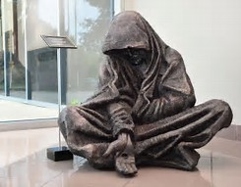
TIMOTHY SCHMALTS, SCULPTOR
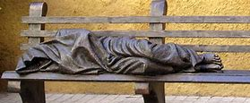
Timothy Schmalz is a Canadian sculptor based out of St. Jacobs, Ontario, Canada. He focuses on religious figures and also has many public pieces. Schmalz is best known for his Homeless Jesus that he created in reaction to the many homeless living on the streets. Schmalz conceives his sculptures with keen devotion to Catholicism and gives his time to each piece, sometimes taking as much as 10 years forming the idea and sculpting it. Some of his works are created in series and others are single pieces. Shmalz has said, "If my sculptures are used by people as a tool to think, then I’m very happy." Instalments of his work have brought his visual message across the globe with Homeless Jesus having been displayed in many places including St. Peter's Basilica.

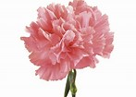
Good Catholic education
“As part of my good Catholic education, as a child I thought the flowers that were worn by fellows in their buttonholes were called ‘incarnations’!” – Brother Barry

^^^^^^^^^^^^^^^^^^^^^^^^^^^^^^
“If you cannot work with love but only with distaste, it is better that you should leave your work and sit at the gate of the temple, and take alms of those who work with joy.”
---Kahil Gibran

^^^^^^^^^^^^^^^^^^^^^^^^^^^^
Who are the most wonderful people in the whole world?
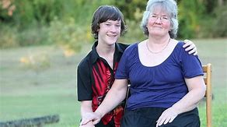
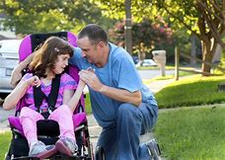
Surely the most wonderful people in the whole world are the many anonymous, selfless, most loving, patient carers!
And some have daily tasks of care that they can never miss. Maybe they have to bathe a loved-one unable to bathe themselves.

Or they may have to get someone dressed every morning and into a wheelchair. And then have to wheel them everywhere, as they are totally dependent.

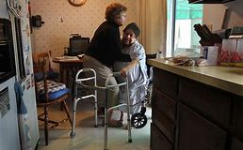
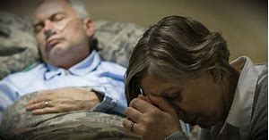
And what training have they had to be these constant carers? Most are just “ordinary” men and women, some just teenagers, who have found themselves in this position through all sorts of circumstances, but who, day after day, faithfully do what is required.

Hopefully those they care for are grateful and say so. But some may be grumpy and demanding, making this sacrifice all the more onerous.

If there are ANY people who will go straight to Heaven, it is surely such carers!
00000000000000000000000000000000000000000000000000000000000000000000000000000000000000000

The Sign of the Cross before the fight
You may have heard the one about the Catholic boxer and his supporter who was attending the fight with a non-Catholic mate. As one of the boxers got into the ring he made the Sign of the Cross. The mate asked what that was. His Catholic friend explained that he prayed to God for success in the fight. The mate asked: “Does it help?” To which the mate replied: “Not if he can’t fight!”
Contacts: St Pius X Catholic Parish Heidelberg West
Father Wayne Edwards: St Pius X Presbytery 419 Waterdale Rd., Heidelberg West 3081
Tel: 9457 5794; Email: stpiusvic@bigpond.com
Exodus Community: 273 Liberty Parade, Heidelberg West, Tel: 9457 7593
School Principal: Barbara Gomez, Tel: 9457 3776 principal@spheidelbergwest.catholic.edu.au
Mass times: Saturday evening Vigil – 7.00pm; Sunday: 9.00am & 11.00am; 12.00 Noon, Exodus Community, 273 Liberty Parade.
Weekdays: 9.00am Tuesday, Wednesday, Thursday, Friday and Saturday
Confessions and Rosary: After 9.00am Mass Saturday mornings
Taize Prayer: Last Friday of the Month, 6.00-7.00pm
Church open for prayer: 8.30am – 4.00pm on school days only
All Aboard editor/compiler: Brother Barry Lamb at barrylamb@hotmail.com or 9456 9641

